ALL FOLDERS AND DATASETS OF ANALYTICS VIDYA ARE IN THIS SAME DIRECTORY ONLY BUT THEY ARE HIDDEN
Variables | Intro 02:37
- Numerical variables 05:03
- Categorical variables 03:43
- Date and time variables 01:58
- Mixed variable
- Variable characteristics 02:43
- Missing data 06:46
- Cardinality - categorical variables 05:03
- Rare Labels - categorical variables 04:54
- Linear models assumptions 09:13
- Linear model assumptions - additional reading resources (optional) 00:35
- Variable distribution 05:08
- Outliers 08:27
- Variable magnitude
Introduction to missing data imputation 03:58
- Complete Case Analysis 06:46
- Mean or median imputation 07:53
- Arbitrary value imputation 06:42
- End of distribution imputation 04:53
- Frequent category imputation 06:56
- Missing category imputation 04:05
- Random sample imputation 14:17
- Adding a missing indicator 05:26
- Mean or median imputation with Scikit-learn 10:33
- Arbitrary value imputation with Scikit-learn 05:35
- Frequent category imputation with Scikit-learn 03:48
- Missing category imputation with Scikit-learn 02:46
- Adding a missing indicator with Scikit-learn 04:06
- Automatic determination of imputation method with Sklearn 08:24
- Introduction to Feature-engine 05:10
- Mean or median imputation with Feature-engine 04:51
- Arbitrary value imputation with Feature-engine 03:30
- End of distribution imputation with Feature-engine 04:46
- Frequent category imputation with Feature-engine 01:38
- Missing category imputation with Feature-engine 02:57
- Random sample imputation with Feature-engine 02:28
- Adding a missing indicator with Feature-engine
Multivariate Imputation 03:31
- KNN Impute 04:22
- KNN Impute – Demo 07:04
- MICE 07:07
- missForest 01:07
- MICE and missForest – Demo
Categorical encoding | Introduction 06:49
- One hot encoding 06:09
- Important: Feature-engine version 1.0.0 00:22
- One-hot-encoding: Demo 14:12
- One hot encoding of top categories 03:06
- One hot encoding of top categories | Demo 08:35
- Ordinal encoding | Label encoding 01:50
- Ordinal encoding | Demo 08:08
- Count or frequency encoding 03:11
- Count encoding | Demo 04:33
- Target guided ordinal encoding 02:50
- Target guided ordinal encoding | Demo 08:30
- Mean encoding 02:22
- Mean encoding | Demo 05:31
- Probability ratio encoding 06:13
- Weight of evidence (WoE) 04:36
- Weight of Evidence | Demo 12:38
- Comparison of categorical variable encoding 10:36
- Rare label encoding 04:31
- Rare label encoding | Demo 10:25
- Binary encoding and feature hashing
Variable Transformation | Introduction 04:48
- Variable Transformation with Numpy and SciPy 07:38
- variable Transformation with Scikit-learn 07:03
- Variable transformation with Feature-engine
Discretisation | Introduction 03:01
- Equal-width discretisation 04:06
- Important: Feature-engine v 1.0.0 00:17
- Equal-width discretisation | Demo 11:18
- Equal-frequency discretisation 04:13
- Equal-frequency discretisation | Demo 07:16
- K-means discretisation 04:13
- K-means discretisation| Demo 02:43
- Discretisation plus categorical encoding 02:54
- Discretisation plus encoding | Demo 05:45
- Discretisation with classification trees 05:05
- Discretisation with decision trees using Scikit-learn 11:55
- Discretisation with decision trees using Feature-engine 03:48
- Domain knowledge discretisation
- Outlier Engineering | Intro 07:42
- Outlier trimming 07:21
- Outlier capping with IQR 06:24
- Outlier capping with mean and std 04:44
- Outlier capping with quantiles 03:17
- Arbitrary capping
Feature scaling | Introduction 03:43
- Standardisation 05:30
- Standardisation | Demo 04:38
- Mean normalisation 04:01
- Mean normalisation | Demo 05:20
- Scaling to minimum and maximum values 03:23
- MinMaxScaling | Demo 03:00
- Maximum absolute scaling 03:01
- MaxAbsScaling | Demo 03:44
- Scaling to median and quantiles 02:45
- Robust Scaling | Demo 02:03
- Scaling to vector unit length 05:50
- Scaling to vector unit length | Demo
https://towardsdatascience.com/feature-engineering-for-machine-learning-3a5e293a5114
https://www.freecodecamp.org/news/feature-engineering-and-feature-selection-for-beginners/

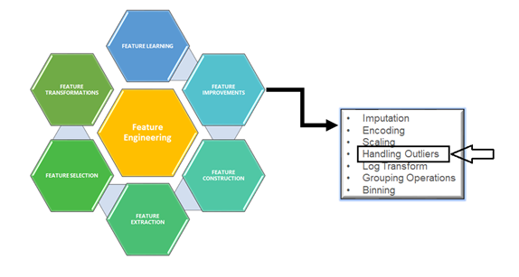

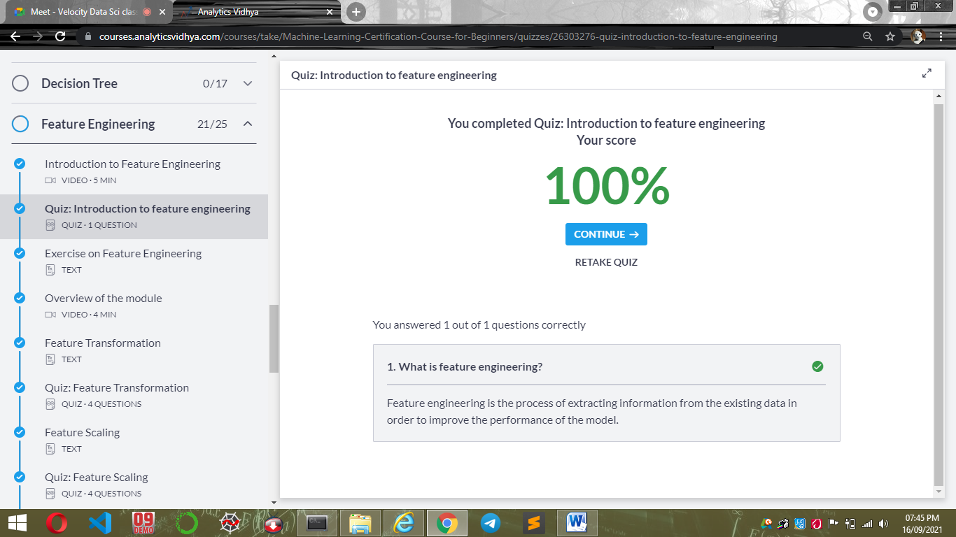

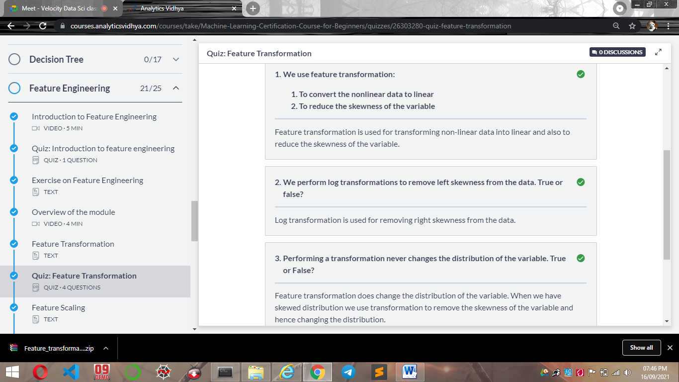
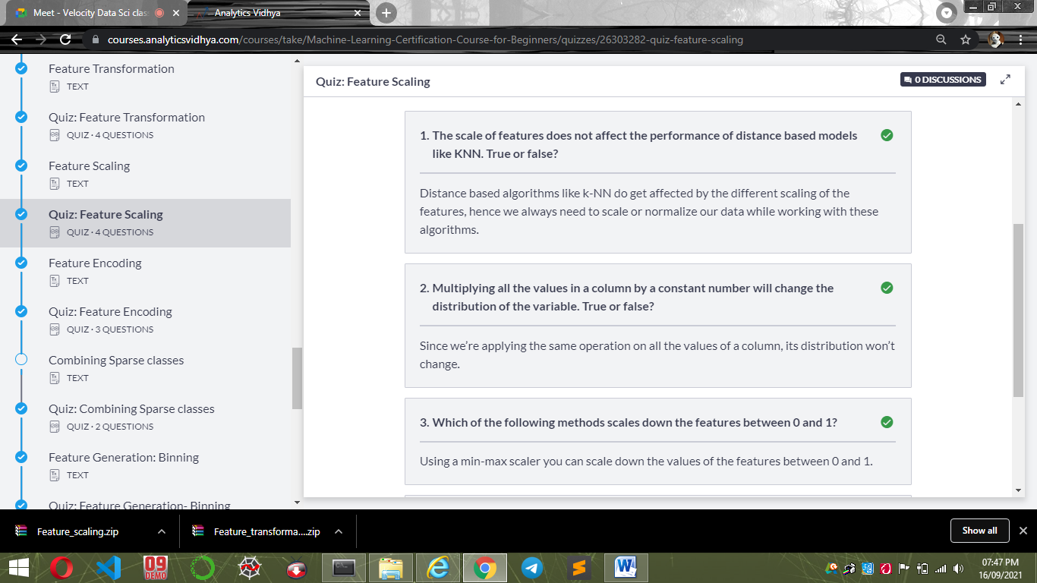

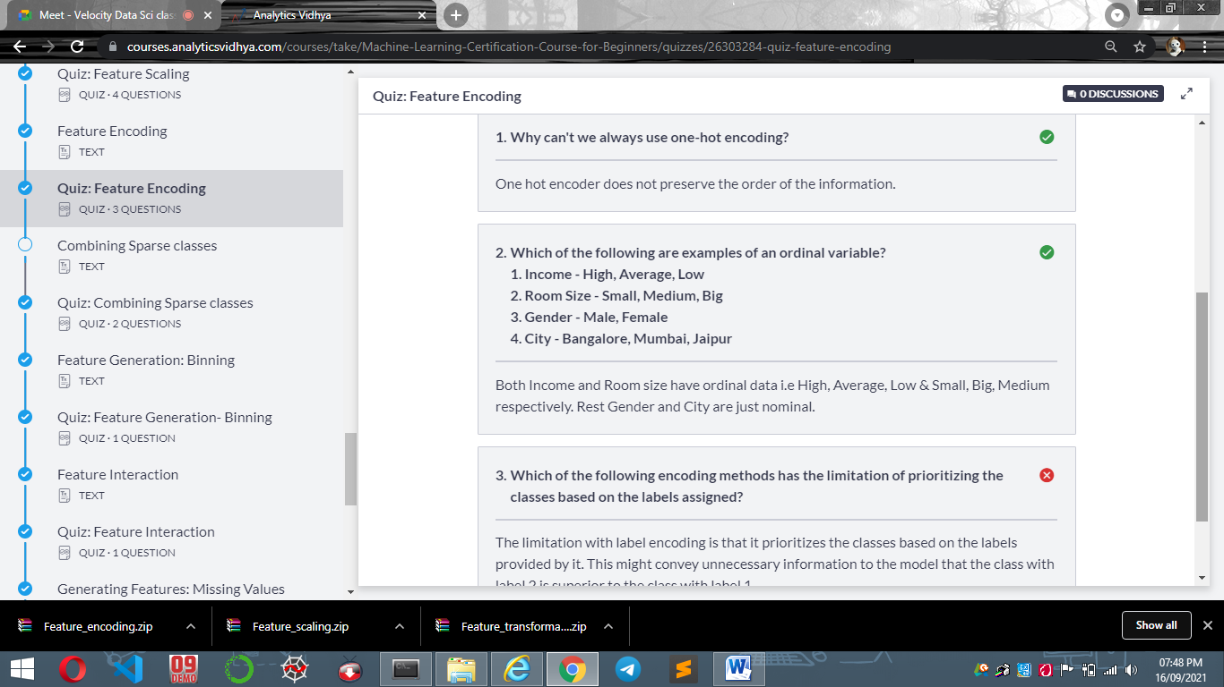
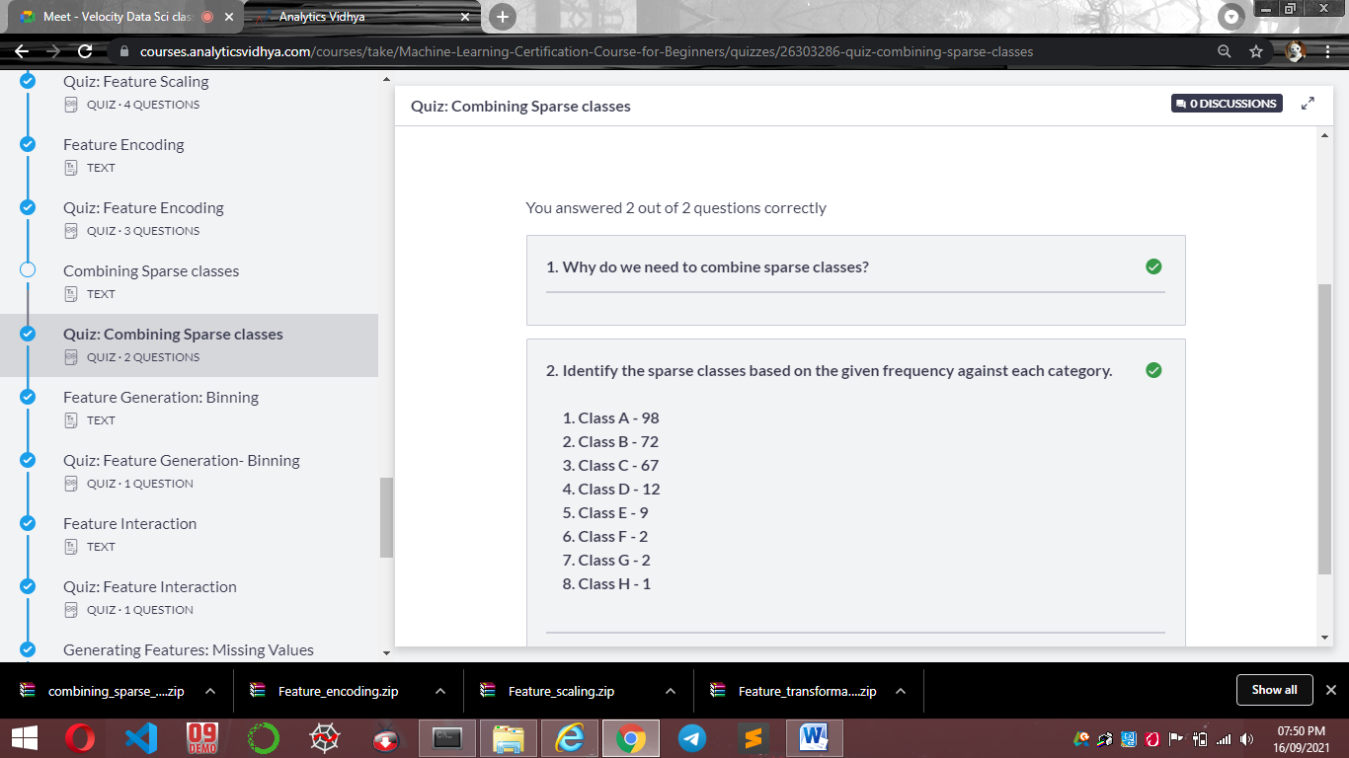
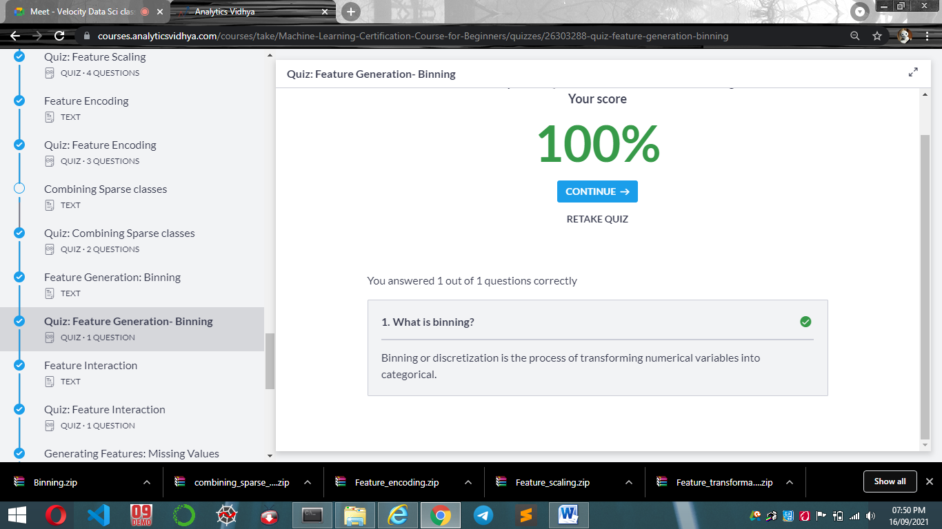
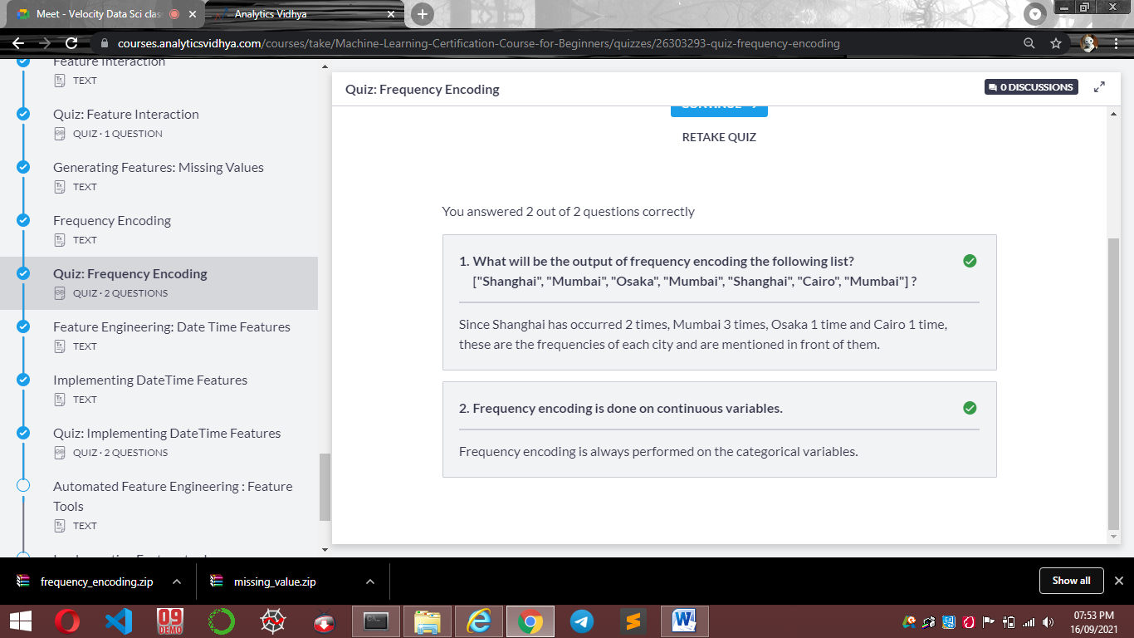
https://pandas.pydata.org/pandas-docs/stable/reference/series.html#datetime-properties
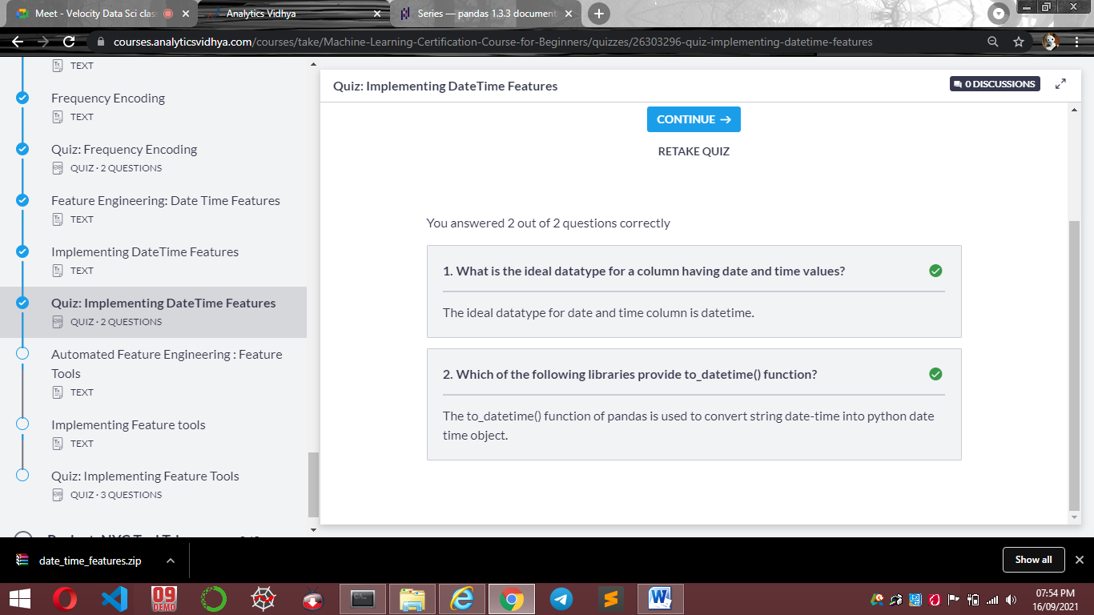
https://featuretools.alteryx.com/en/stable/
